**Supplementary Information - 2**

**Two-stage Adaptive Modelling Framework for Long-term Monthly Operation of a Multi-purpose Reservoir for Regulating Environmental Flows**

**Ruby Jose1and Srinivasan K2**

1Former Research Scholar, 2Professor (Retd.), Department of Civil Engineering, Indian Institute of Technology Madras, Chennai – 600036.

Corresponding author: Ruby Jose. J ([rubyphdwork@gmail.com](mailto:rubyphdwork@gmail.com))

Address: Department of Civil Engineering, IIT Madras, Chennai 600036, India.

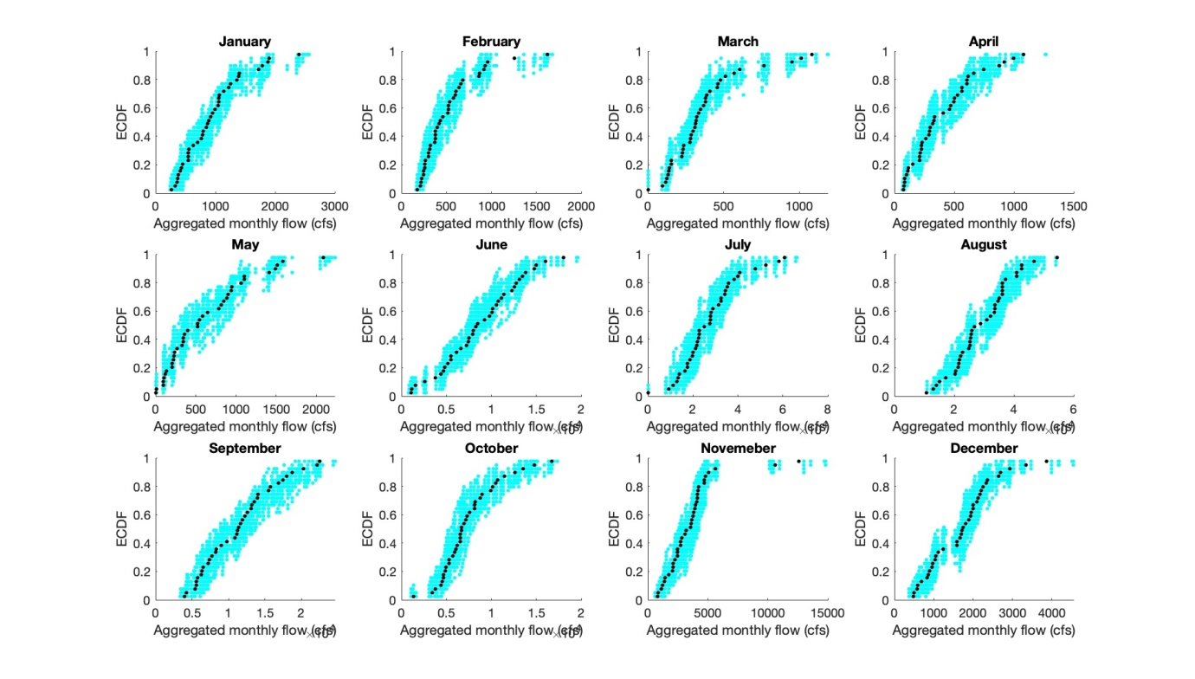

**Fig. S– 2.1: Reproduction of the Aggregated Monthly empirical cumulative distribution functions**

The empirical cumulative distribution function (ECDF) plots for the twelve months demonstrate the close agreement between observed (black) and synthetic (cyan) monthly stream flows, pointing to the reproduction of the temporal distribution of flow volumes at the monthly scale.

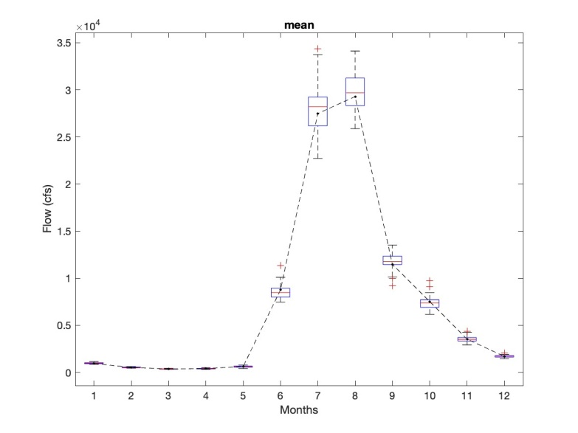 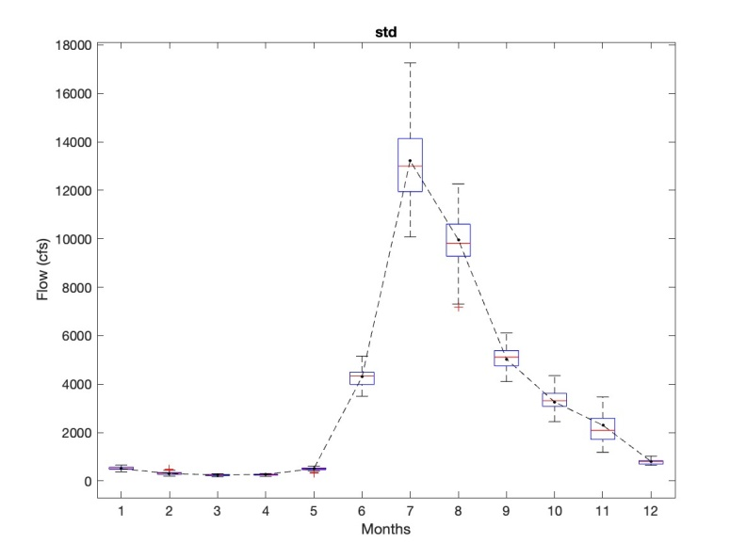

1. (b)

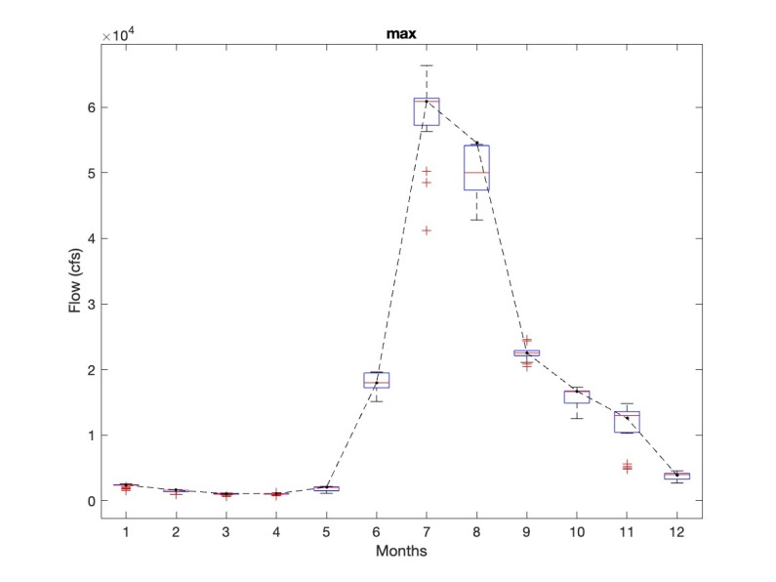 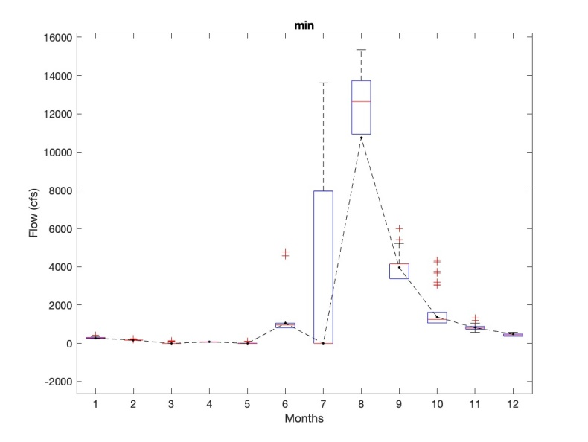

(c) (d)

**Fig. S– 2.2: Boxplots of monthly flow statistics - comparison of monthly flow statistics estimated using observed and synthetically generated flow data: (a) mean; (b) standard deviation; (c) maximum; and (d) minimum**

Boxplots of monthly statistics such as mean, standard deviation, maximum, and minimum flows are also well replicated by the synthetically generated flows, with some overestimation (Fig. S-2.2).

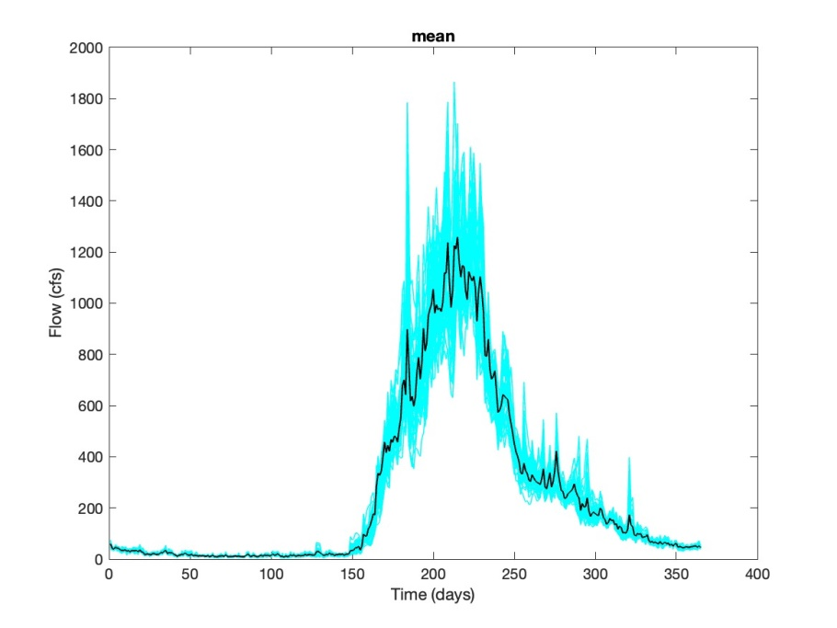

(a)

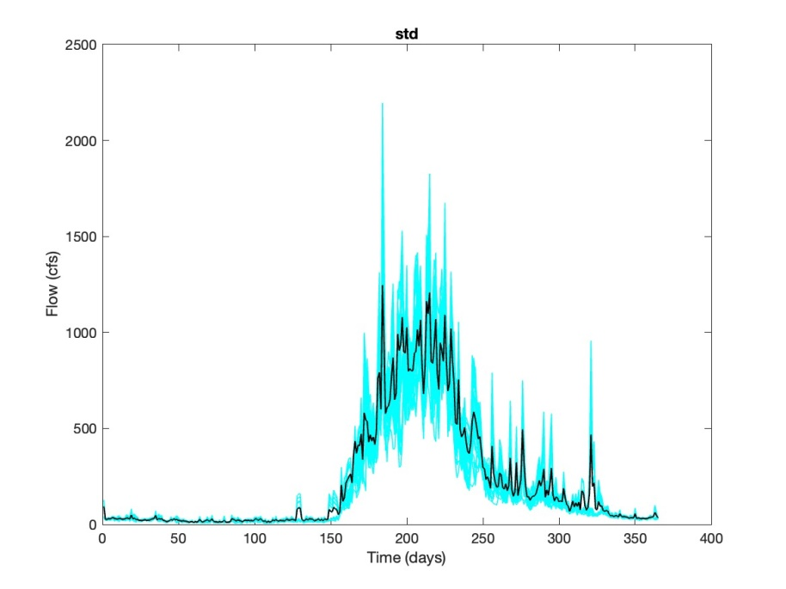

(b)

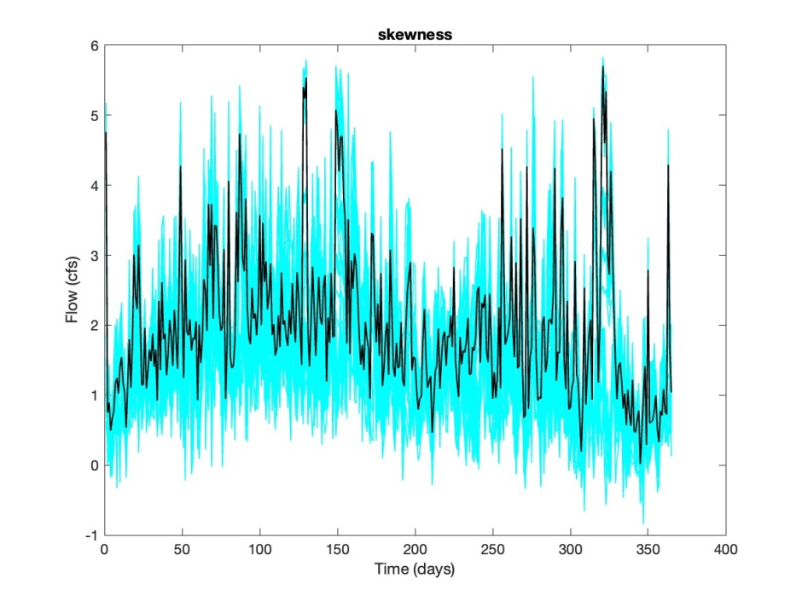

(c)

**Fig. S– 2.3: Reproduction of daily flow statistics: (a) mean; (b) standard deviation; and (c) skewness coefficient**

Figure S- 2.3 presents the reproduction of the daily flow statistics in the generated stream flow data with sufficient variability.